Reverse Osmosis Desalinators
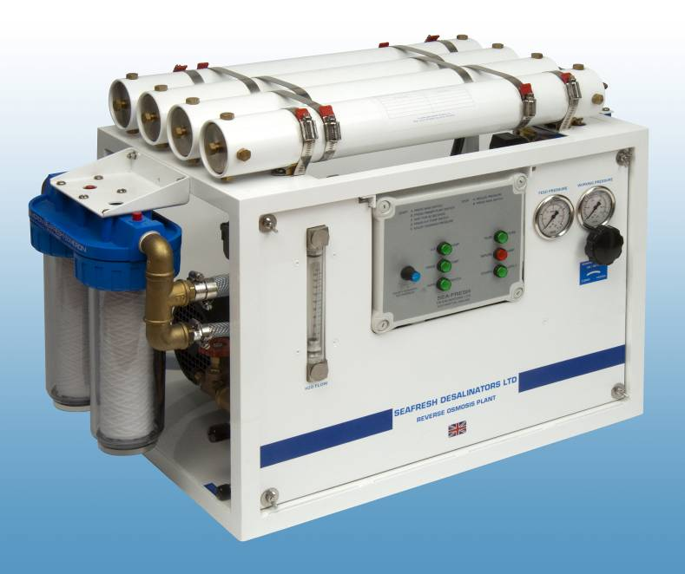
H2O6 Unit
Technical Specification

with a capacity of 104Ltr/Hr
(2.496m³/Day or 658.94 US gall/day)

System Summary
Model Number: H2O6
Production Capability: 104Ltr/Hr (2.496m³/Day) or 27.46 US gall/hr (658.94 US gall/day)
Electrical Load: 1.5kW
Current Draw: Approx 10Amps at 230V
Std Voltage Options: AC:- 440V/3-Phase, 380V-3 Phase, 230V-1 Phase, 110V-1 Phase (all 50Hz or 60Hz)
DC: 12V or 24V
Footprint & Weight *: Std Frame, 737mm (L) x 432mm (W) x 711mm (H), 90kg
(29” (L) x 17” (W) x 28” (H), 199lb)
Space saving frame, 780mm (L) x 410mm (W) x 500mm (H), 90kg
(31” (L) x 16” (W) x 20” (H), 199lb)
Finished in white powder coat, (Interpon MC068E)
* Framed unit. Also available as separate components, panel and pressure vessel for limited spaces

System Design Parameters
Feed water flow: 0.78m3/Hr (US gall/hr)
Feedwater pressure: 20PSI (1.4BAR)
Salt rejection: 98.6%
Pressure: 850PSI (58 BAR)
Feed water salinity: 36,000ppm, pH7, 25ºC
Operating water temperature: 5ºC to 35ºC
Product flow/membrane rating: +/-15%
Product water quality: <450ppm

Principles of Reverse Osmosis
Reverse Osmosis (RO) is a low cost method of desalination, and is excellent for both marine and land based applications. The plants provide an excellent water making capacity when compared to the relatively small footprint of the plants.
Osmosis is a naturally occurring process and is defined that when two solutions of different concentrations are separated by a semi-permeable membrane then the less concentrated (purer) water will flow towards the saltier (more concentrated) side of the membrane. This will happen until the pressures and concentrations are equalised.
The Cathelco Seafresh desalination plant reverses this process by pressurising salt water at double the natural osmosis pressure against the membrane surface, resulting in potable water being produced.

The principal of operation is such that the feed water has passed through a strainer (or similar) to ensure feedwater is free of large debris before entering the system. Sea water is pumped by a priming pump through a series of pre-filters to extract any free particles to a designed micron size according to the operating conditions.
The filtered feed water then passes through the high pressure pump which increases the pressure to 800 – 900 PSI (55-62 BAR) prior to entering the membrane(s).
Each membrane is held in the centre of a high pressure casing. The pressurised feed water is fed through the membranes and discharged through a pressure regulating valve to sea water discharge.
The product water which permeates through the membranes is piped through a salinity sensor to a solenoid valve which diverts the fresh water to store, and impure water to dump, this is controlled by a plug-in controller set to reject water that is not well within the WHO directive of a maximum 500ppm salinity for potable water.
Although the product water is suitable for potable storage directly from the Cathelco Seafresh plant, it can be treated in various ways i.e. ultra violet sterilisation, active carbon filter, chlorination etc. These are available as optional extras and are detailed later in the document.
Product water without chlorine treatment tastes better but for long term storage chlorine dosing is advisable.
Every unit is manufactured to Cathelco Seafresh exacting standards, and is comprehensively tested prior to despatch to ensure safety and operational excellence.

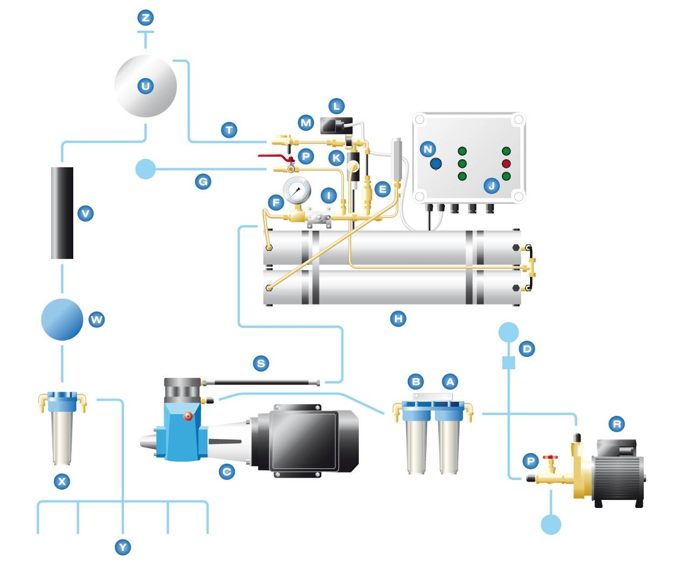

Component Description
- Primer Pump (R in the diagram)
The function is to force water through the pre-filter units and to deliver to the high pressure pump with a positive pressure.
Type: Single stage centrifugal
Materials: Aluminium bronze body, plastic impeller.
Capacity: 0.78m³/hr
Speed: 2800rpm
Rated output of electric drive: 0.55kW

- Pre-filters (A and B in the diagram)
Two disposable cartridge filters mounted in series fitted with bleed screws for simple removal of air from the system. Firstly a 50 micron rated filter followed by 5 micron ensures “clean” water passes into the high pressure pump and pressure vessels to prevent damage. The clear filter housing makes it easy to see the elements and when they are in need of cleaning/replacing. Polyester elements are used instead of cotton as they are a poor host for bacteria and fouling, but cotton elements are used to absorb traces of oil in feedwater.
Capacity: 1.0m³/hr
Filter cartridges: Polyester fibre elements, 50µm and 5µm 250mm (10”)

- Feedwater Flow
The Cathelco Seafresh RO units use optimum saltwater flow rates to give maximum self flushing effect for long membrane life, by preventing mineral and bio-fouling from depositing and settling on the semi-permeable membranes.

- High Pressure (HP) Pump (C in the diagram)
Triple plunger pump with ceramic plungers, corrosion resistant nickel aluminium bronze or duplex pump head and oil bath crankshaft in alloy crankcase. The AC pump motors are available as close couple or belt driven options. The close coupled is easier to maintain, whereas the belt driven option gives more flexibility with varying run speeds available.
Service interval: 5000hrs full overhaul

- Pressure vessels and membranes (H in the diagram)
The pressure vessels are constructed of PVC sleeved aluminium tube with bronze end plugs and fittings made from NAB. The pressure vessels have been designed to withstand more than 4x operating pressure, and have been independently tested up to 2000PSI, to ensure maximum safety in operation.
No. Of pressure vessels: 3x 530mm (21”) x 64mm(2.5”)
Pressure vessel material: aluminium with white powder coast finish
Membrane type: Dow Filmtec SW30 Spiral Wound
Product Flow: 104Ltr/Hr (3x 21” x 2.5”, 36Ltr/Hr)
Chloride rejection: 99.5%
Max operating pressure: 800 -900PSI(55-62BAR)

- Connections (G, P, T in the diagram)
3/4” BSP sea water inlet from seacock and primary strainer
1/2” / 3/8” BSP Brine discharge to overboard.
1/2” BSP product connection to tank manifold

- Control Panel/Gauges/Instrumentation (E, I, J, K, L, N in the diagram)
Simple electronic controls for ease of operation.
All electronic enclosures rated to IP55
Pressure gauge
Salinity control sensor

Optional Extras

Fresh Water Flush: Upon system shutdown the unit flushes potable water through the system to remove any bacteria, minerals, etc to ensure maximum operational efficiency and longevity.

Oil/water separator: A pre-treatment for use in water containing oil. The unit is the same housing as the standard pre-filters for compatibility and ease of replacement. The element is constructed from a cotton fibre and comes in standard 250mm size (10”).

Media Filter: This is a large diameter housing containing specially calibrated filter media. The water passes through the media where large particles get caught in the upper layers of the media. The flow can be reversed to flush the “dirt” out through the discharge pipe. This unit significantly lowers the consumption of the cartridge filter elements when the plant is operated in dirty water. The diameter of the tank is important and the larger the surface area the more efficient and effective the unit will operate. Commonly referred to as a sand filter because the filter media is borosilicate grit which looks like beach sand.

UV steriliser: The unit sterilises the water to be completely free from bacteria, parasites and algae spores. This can be used as a pre-treatment when operating in dirty waters and also as a post treatment if the water has been held in storage for long periods of time. (V in the diagram)

Chlorinator: The unit sterilises the water to be completely free from bacteria, parasites and algae spores. An alternative method of sterilisation to UV is to add chlorine to the product water (0.2-0.3mg/l in accordance with W.H.O rules on potable water) to sterilise it for storage for long periods of time. A brominator works in the same principle by sterilising through adding bromine gas to the product water. (V in the diagram)

Carbon filter: Removes dissolved gases (incl. chlorine), tastes and odours to improve the taste of the product water. This unit uses the same housing as the pre-filtration cartridges for compatibility and ease of replacement. (X in the diagram)

Re-mineralisation unit: used to restore mineral content and restore equilibrium with alkalinity/CO2 levels . Also known as re-hardening or de-acidifcation.

